
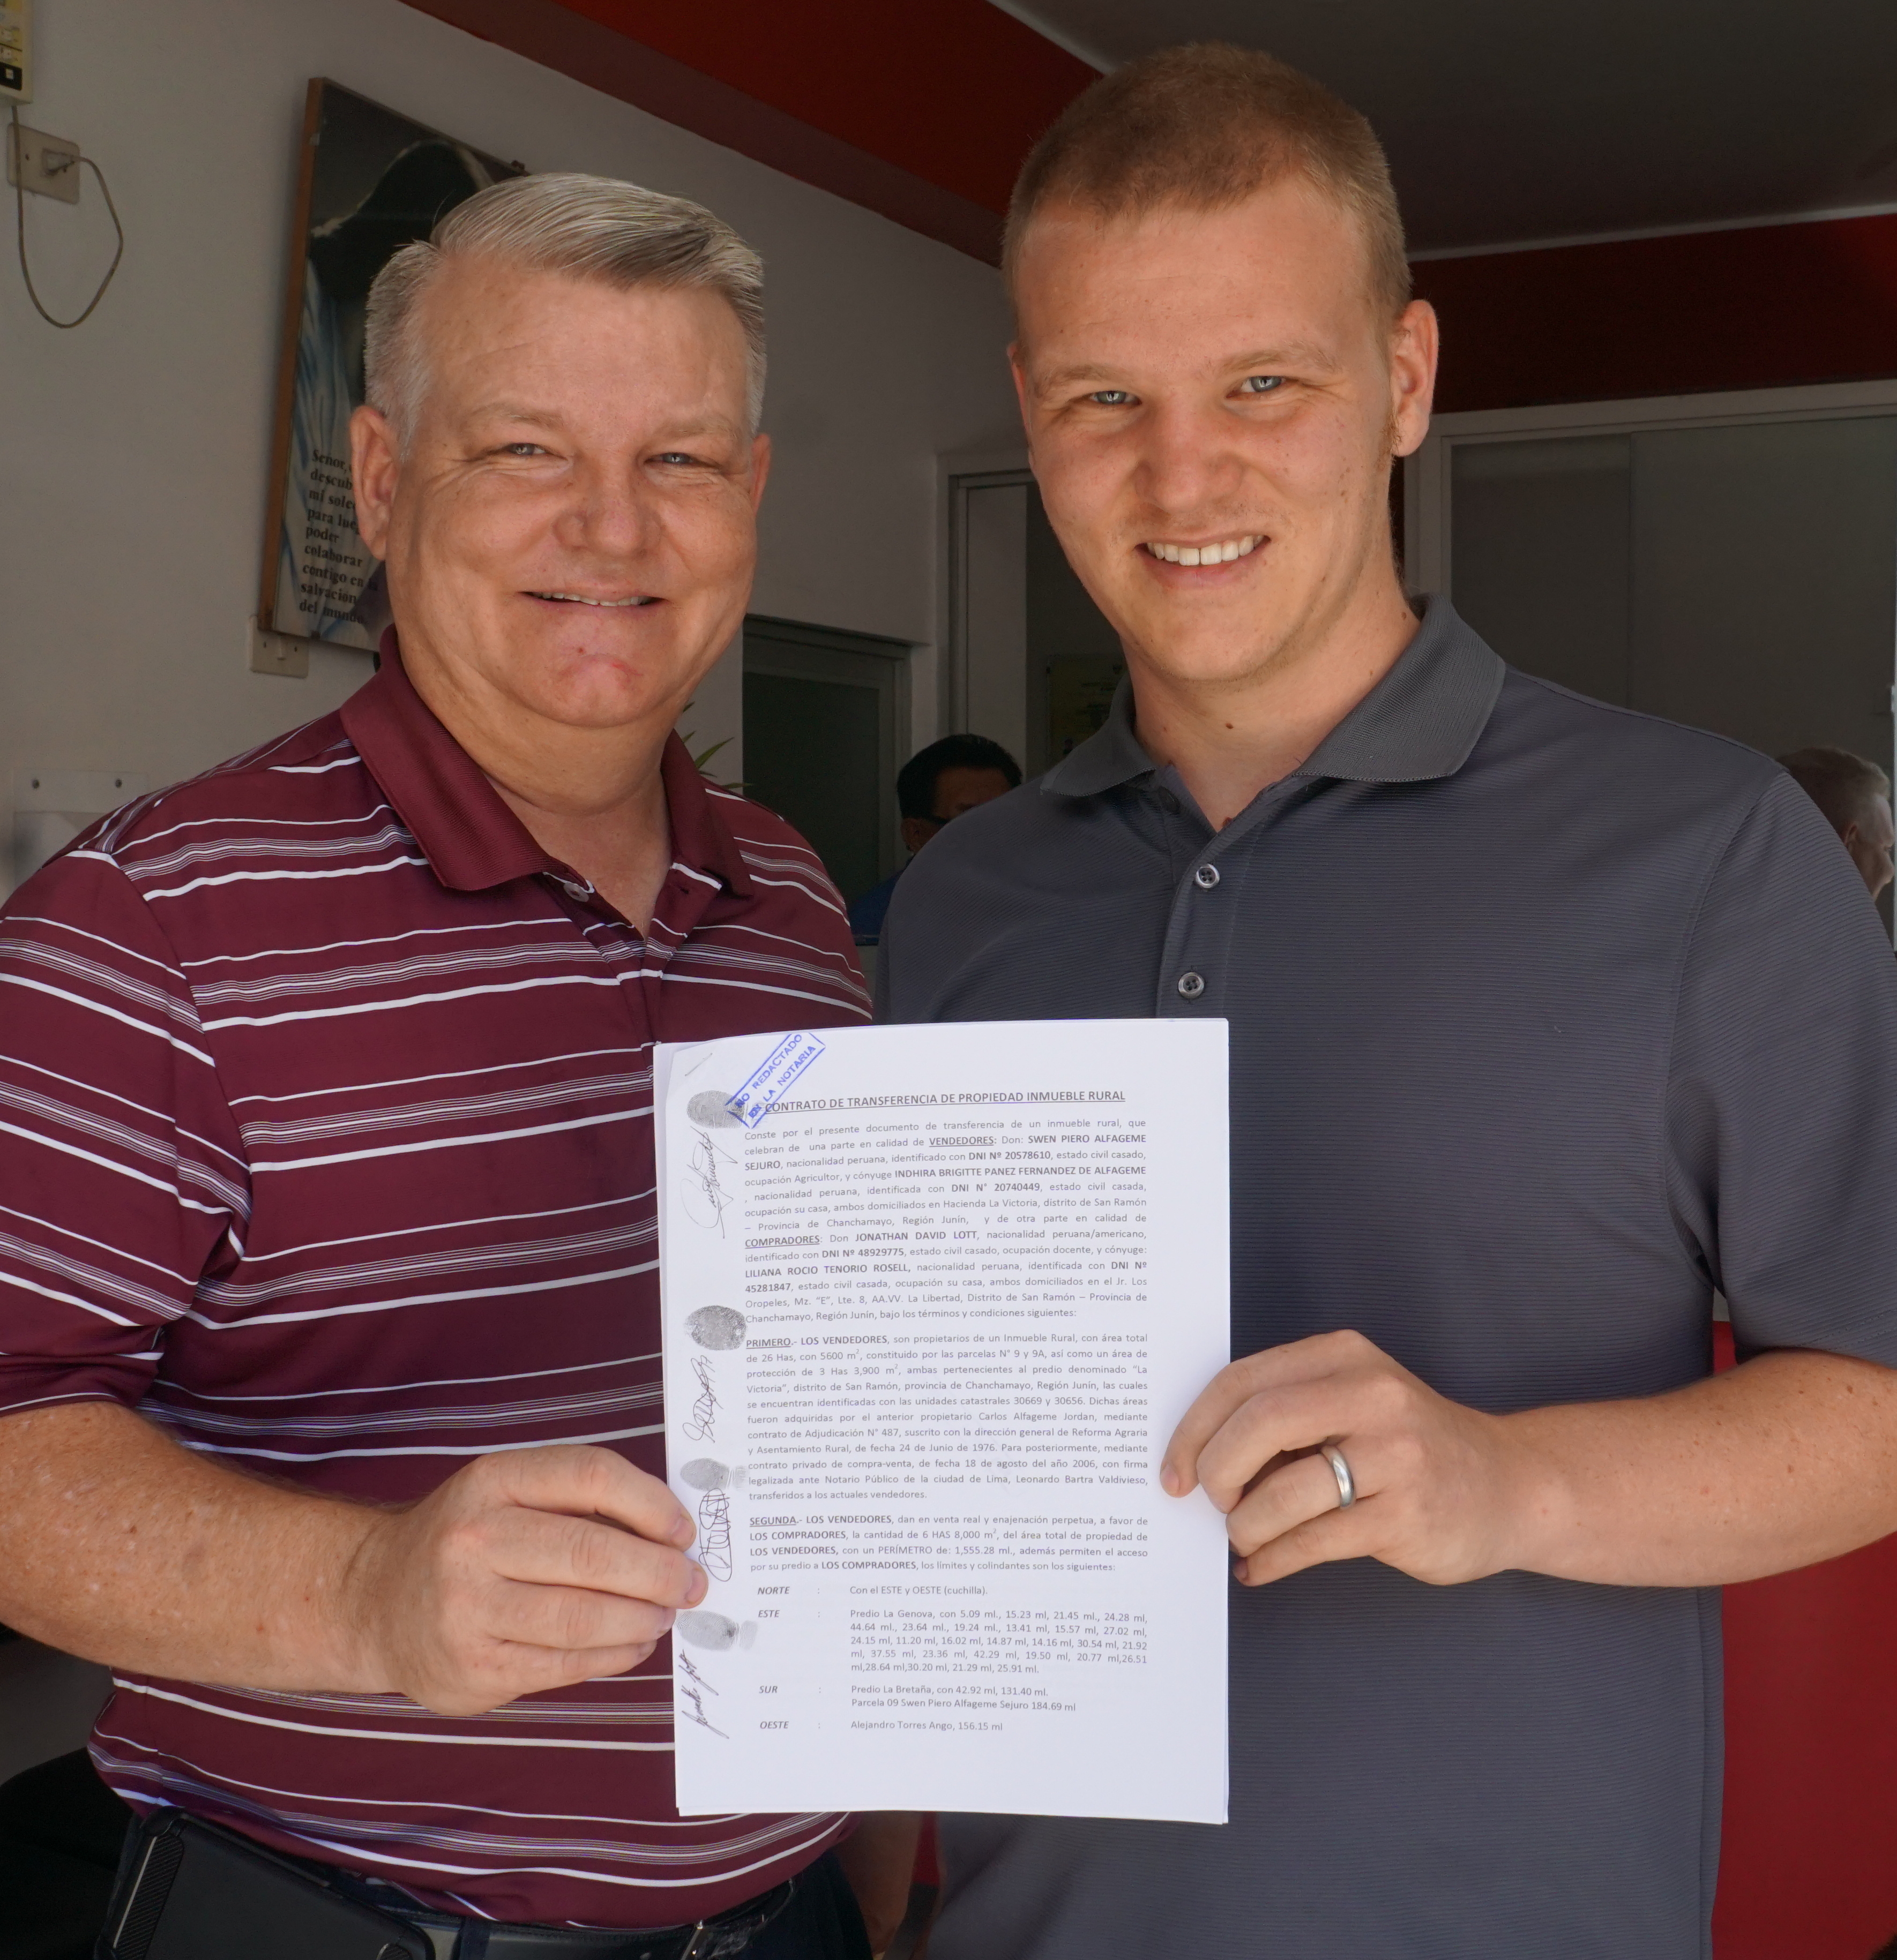
NUEVO TRATADO PUBLICADO
SEPTEMBER 2018
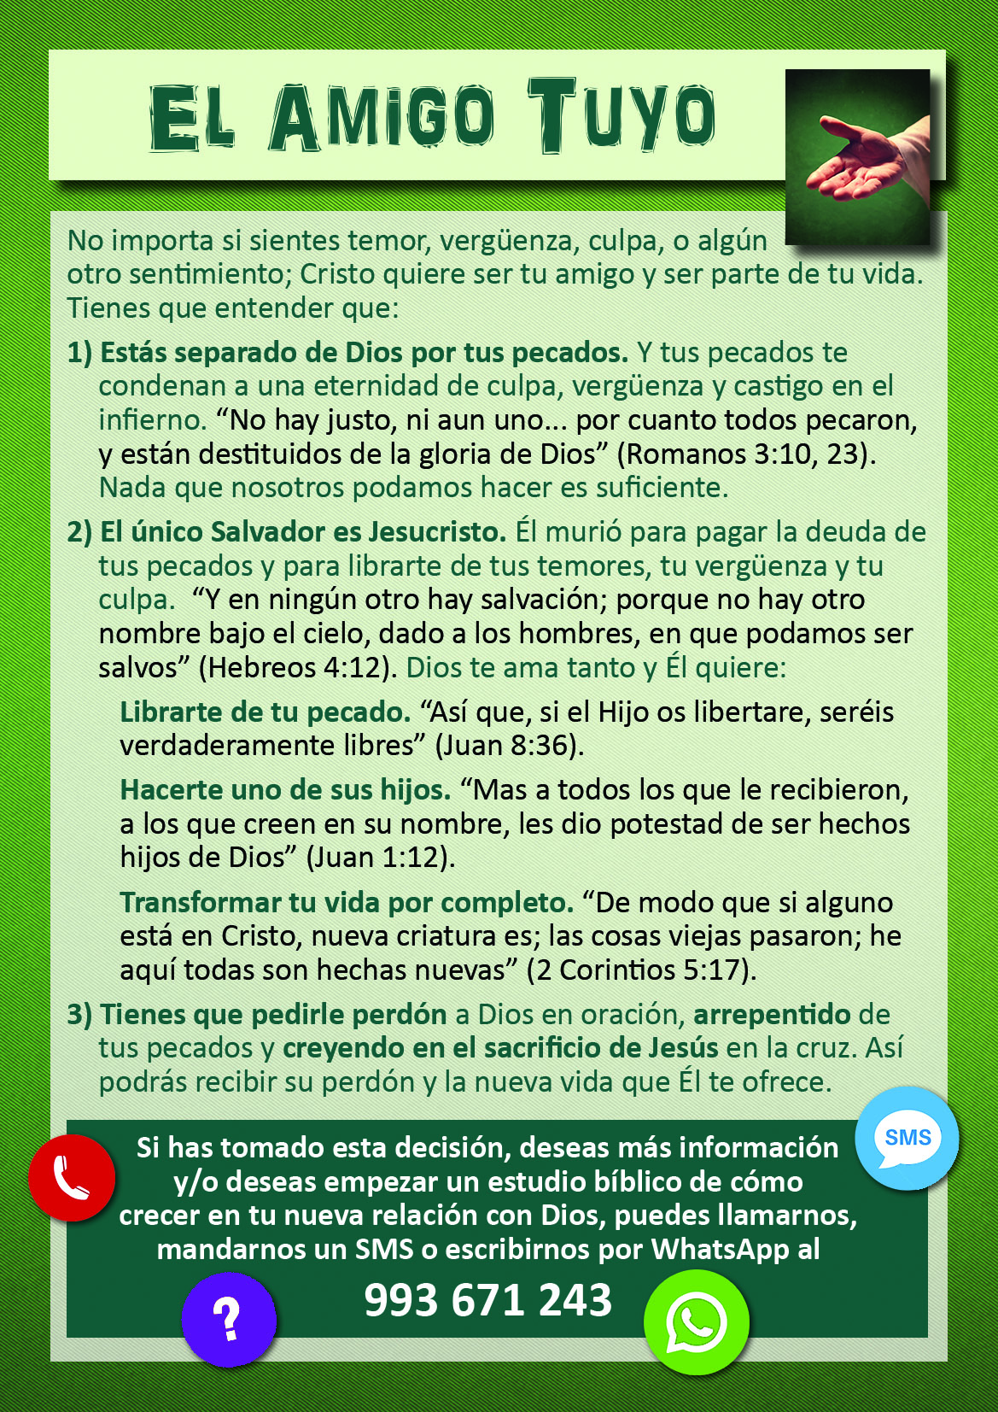
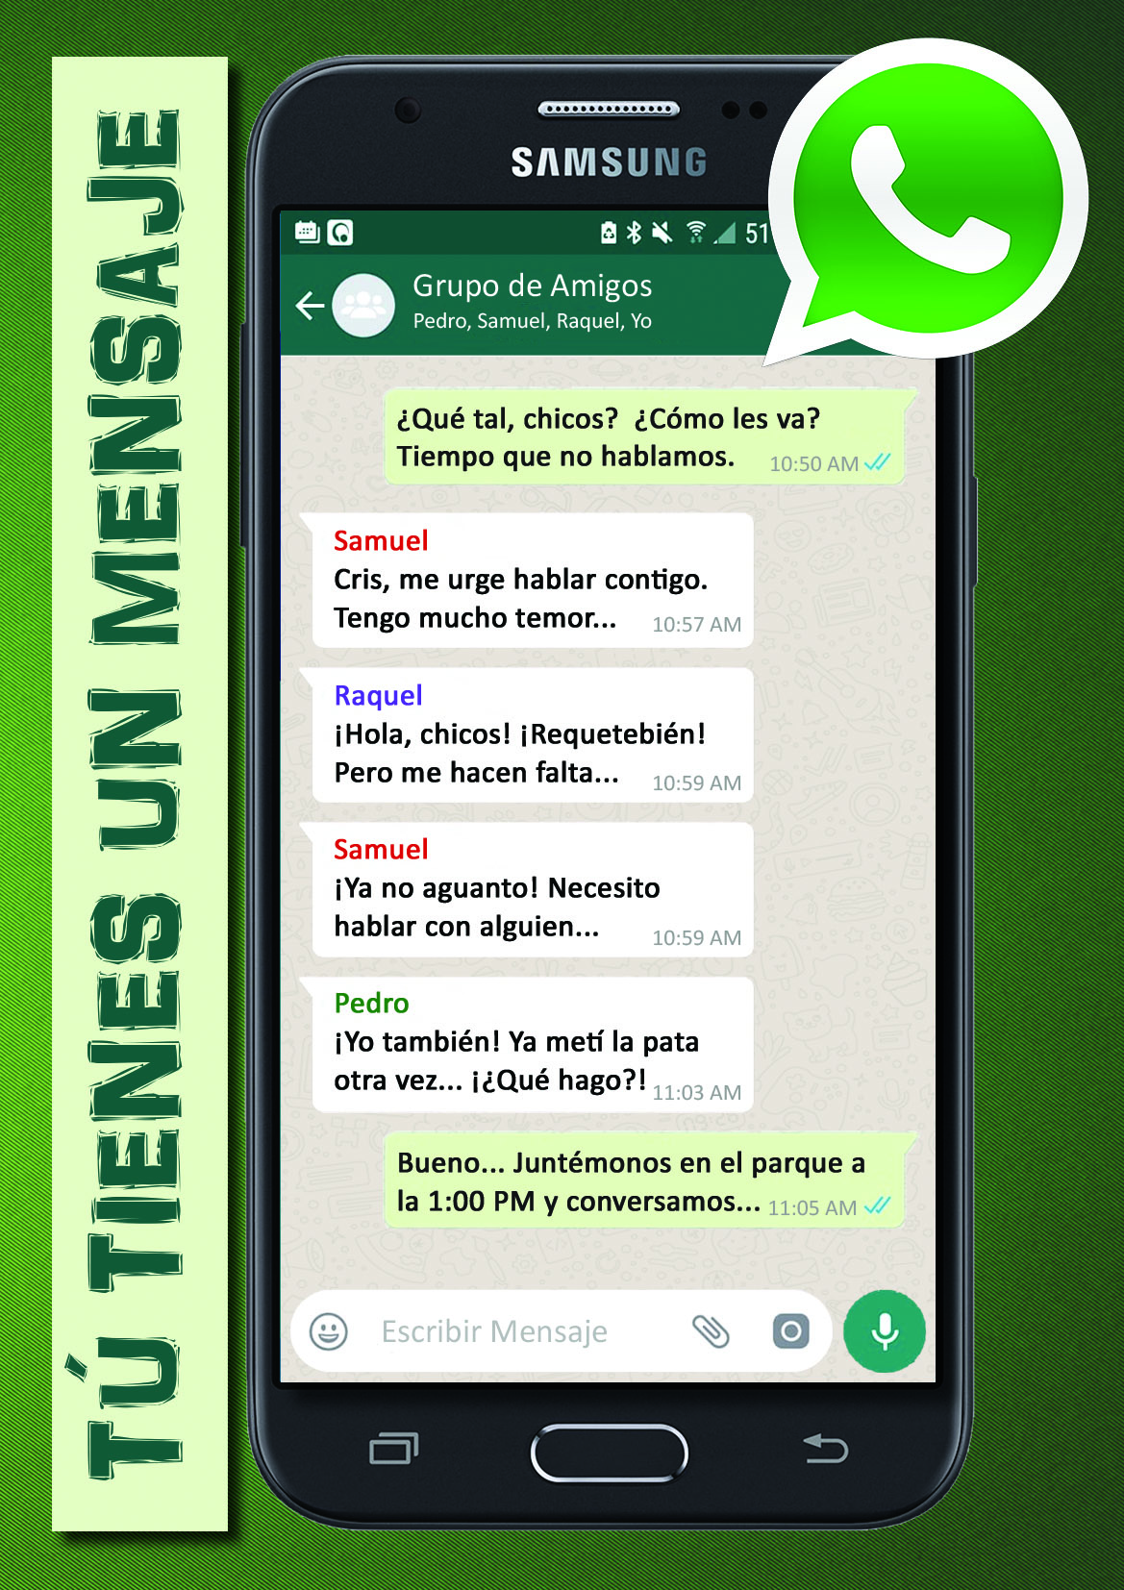
En nuestra última carta, pedimos oración por un nuevo tratado que estábamos desarrollando para la Selva Central. Aquí en Perú (como en casi todo el mundo), WhatsApp es muy comúnmente usado para enviar mensajes y comunicarse con amigos y familia.
Después de orar y meditar sobre lo que el Señor quisiera que hagamos, hemos desarrollado y publicado un nuevo tratado, “Tú Tienes Un Mensaje”. Es una historia de un joven con tres amigos, cada uno con necesidades diferentes. Él les manda un mensaje por WhatsApp y luego se encuentran en un parque. Después de escuchar sus historias, él decide presentarles un nuevo amigo que tiene, que ha transformado su vida por completo. Por supuesto, ¡ese nuevo amigo es Jesús!
We are praying that the Lord will widely use this track in the lives of people searching for answers in their lives. We had 15,000 tracts printed and have already distributed about 3,000 or so. Please pray for souls to be saved by the power of the Gospel in the lives of the readers.
NEW LAND PURCHASED
Since Jonathan came to the Central Jungle more than 4 years ago, his heart’s desire has been to have a full-time Bible Institute where students can live, work, study and prepare for the ministry without having to travel to Lima (some 8 hours away by bus). That dream has taken a huge step forward since our last letter! After much prayer, counsel, looking at land, and possible financial resources. God has allowed us to purchase just over
15 acres of land near San Ramón for the building of the Central Jungle Bible College. God provided a very low interest loan for the purchase through a faithful lady in the States. It is now our goal to have the College ready to receive students by the next school year in March of 2019. There is a lot of work to be done between now and then, but we are confident that this is the direction that the Lord has for the ministry here. We will be giving more information regarding the building and development plans soon. In the meantime, praise the Lord with us!
NEW DISCIPLESHIPS STARTING
God has begun opening hearts and doors in the town of Vitoc where we have been witnessing for a good while. I have begun to disciple a man named Richard, and my wife has started discipling a lady named Marleny. Pray especially for Marleny’s husband, Carlos. He recently had a burst appendix that became life threatening. Praise the Lord that they were able to operate in time, and Carlos is now back home recovering. He supposedly has told his wife that he was sorry for having quit church a few years back. Pray that he is sincere in his desire to rededicate his life (if he is saved), or that he would soon be saved (if he is not). God is working in Vitoc!

